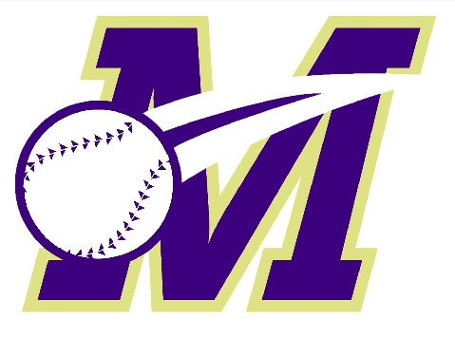 | Monroe Township Baseball Association’s  5th Annual Summer Baseball Tournament  Fundraiser for
 | July 9-12 and 16-19, 2020

ABOUT THE TOURNAMENT
The MTBA is very proud to host our 5th annual tournament to benefit Make-A-Wish New Jersey. Our goal is to raise awareness and make a sizable donation to Make-A-Wish New Jersey while promoting a great and memorable youth baseball experience. Our first four tournaments have raised in total over $45,000 for MAW-NJ and have helped grant eight wishes for very deserving children! For more info on Make-A-Wish New Jersey please visit http://nj.wish.org.

This promises to be a memorable tournament for all participating teams,
RAISING FUNDS AND AWARENESS FOR A GREAT CAUSE!!

- 7U-10U (46/60), 11U-12U (50/70), 13U (60/90)
- Four to six teams per bracket, three game minimum (weather permitting)
- "A" and "B" brackets for all age groups except 13U
- "B" brackets are for true "B" town recreation all-star teams, no club teams
- July 9-12, 2020: 7U/B, 8U/B, 9U/B, 10U/B, 11U/A, 11U/B
  - [7U/B is 2-day tourney, 7/11-12: 7U/B is a player pitch (2 inn)/coach pitch (4 inn) bracket]
- July 16-19, 2020: 7U/A, 8U/A, 9U/A, 10U/A, 12U/A, 12U/B, 13U
  - [7U/A is 2-day tourney, 7/18-19: 7U/A is a player pitch (2 inn)/coach pitch (4 inn) bracket]
- All games (except 13U) at James Monroe Park -- rest rooms, full-service snack bars, bleachers, lawn-chair areas, wi-fi, and live streaming on the web:
http://www.monroebaseball.com/jmp-web-cam-info
- NJ state federated umpires for all games
- $650.00 per team ($475.00 for 7U); checks made to MTBA
- League multi-team discounts available (teams must register and pay together):
  - 3 or more teams = $600/team ($425/team for 7U)
- 30% of all registration fees will be donated directly to MAKE-A-WISH NEW JERSEY

Please visit www.monroebaseball.com for more info
All teams must carry their OWN insurance and send the COI prior to the start of the tournament.
Insurance certificate holder on COI must read what is posted on the 3rd page of this flyer!

MTBA 5th ANNUAL MAKE-A-WISH NJ BASEBALL TOURNAMENT

REGISTRATION FORM
(Please fill out this registration form for EACH team you are registering)

Age Group | 7U 8U 9U 10U 11U 12U 13U
Bracket | “A” “B”
Team Name
Manager’s Name
Manager’s Mailing Address
Manager’s Email Address
Manager’s Cell Phone
Affiliated Rec League
(where applicable)

TEAM ROSTER

Name | Number | Age | Date of Birth
ADDITIONAL INFO…
- For questions, please contact tournament directors Mike Maiolo (fmmaiolo@aol.com / 908-227-2977) or Jessica Balz (jessica.k.balz@gmail.com / 732-677-8481), or email the MTBA at monroebaseball@gmail.com
- You may email this form to the three email addresses above to hold your spot for up to 21 days without payment
- Spots may not be held after June 1, 2020 without payment in full; all tournament fees are non-refundable
- INSURANCE CERTIFICATE (COI) HOLDER MUST READ:
Monroe Township
1 Municipal Plaza
Monroe Twp, NJ 08831

- Please mail registration/roster form, payment (check made out to MTBA), and copy of COI to:
Monroe Twp Baseball Association
120 Monmouth Rd.
Monroe Twp, NJ 08831

- Tournament directors will handle all schedule changes and re-scheduled games due to inclement weather; no schedule changes once the schedules are posted; most communication will be done via email and the tournament web site
- Each Monroe manager will act as a bracket host; please see below for list of hosts for each bracket

Bracket | MTBA Host Manager | Manager Email | Manager Cell
7U(A) | Frank Juliano | Fjuliano734@gmail.com | 732-259-7531
7U(B) | Oliver Minguillon | oliver.minguillon@gmail.com | 973-943-6141
8U(A) | Martin Kappus | kappusmartin@gmail.com | 908-872-7016
8U(B) | Michael Carrig | carrigmm@gmail.com | 908-910-8122
9U(A) | Jason Rutan | jasonrutan@aol.com | 732-619-5412
9U(B) | Charley Wojcik | charleywoj11@gmail.com | 732-770-0350
10U(A) | Mike Brown | michaelbrownnj@gmail.com | 732-259-9004
10U(B) | Martin Kappus | kappusmartin@gmail.com | 908-872-7016
 | Eric Johnson | eric_johnson715@msn.com | 732 -690-2298
11U(A) | Mike Maiolo | fmmaiolo@aol.com | 908-227-2977
11U(B) | Jessica Balz | Jessica.k.balz@gmail.com | 732-677-8481
12U(A) | Jason Kovler | jasonkovler@gmail.com | 609-647-6616
12U(B) | Chris Fornal | cfornal@aol.com | 732-910-4729
13U | Jim McCauley | ppg11@verizon.net | 732-991-8152

www.monroebaseball.com

@MonroeTownshipBaseball
@monroe.baseball

