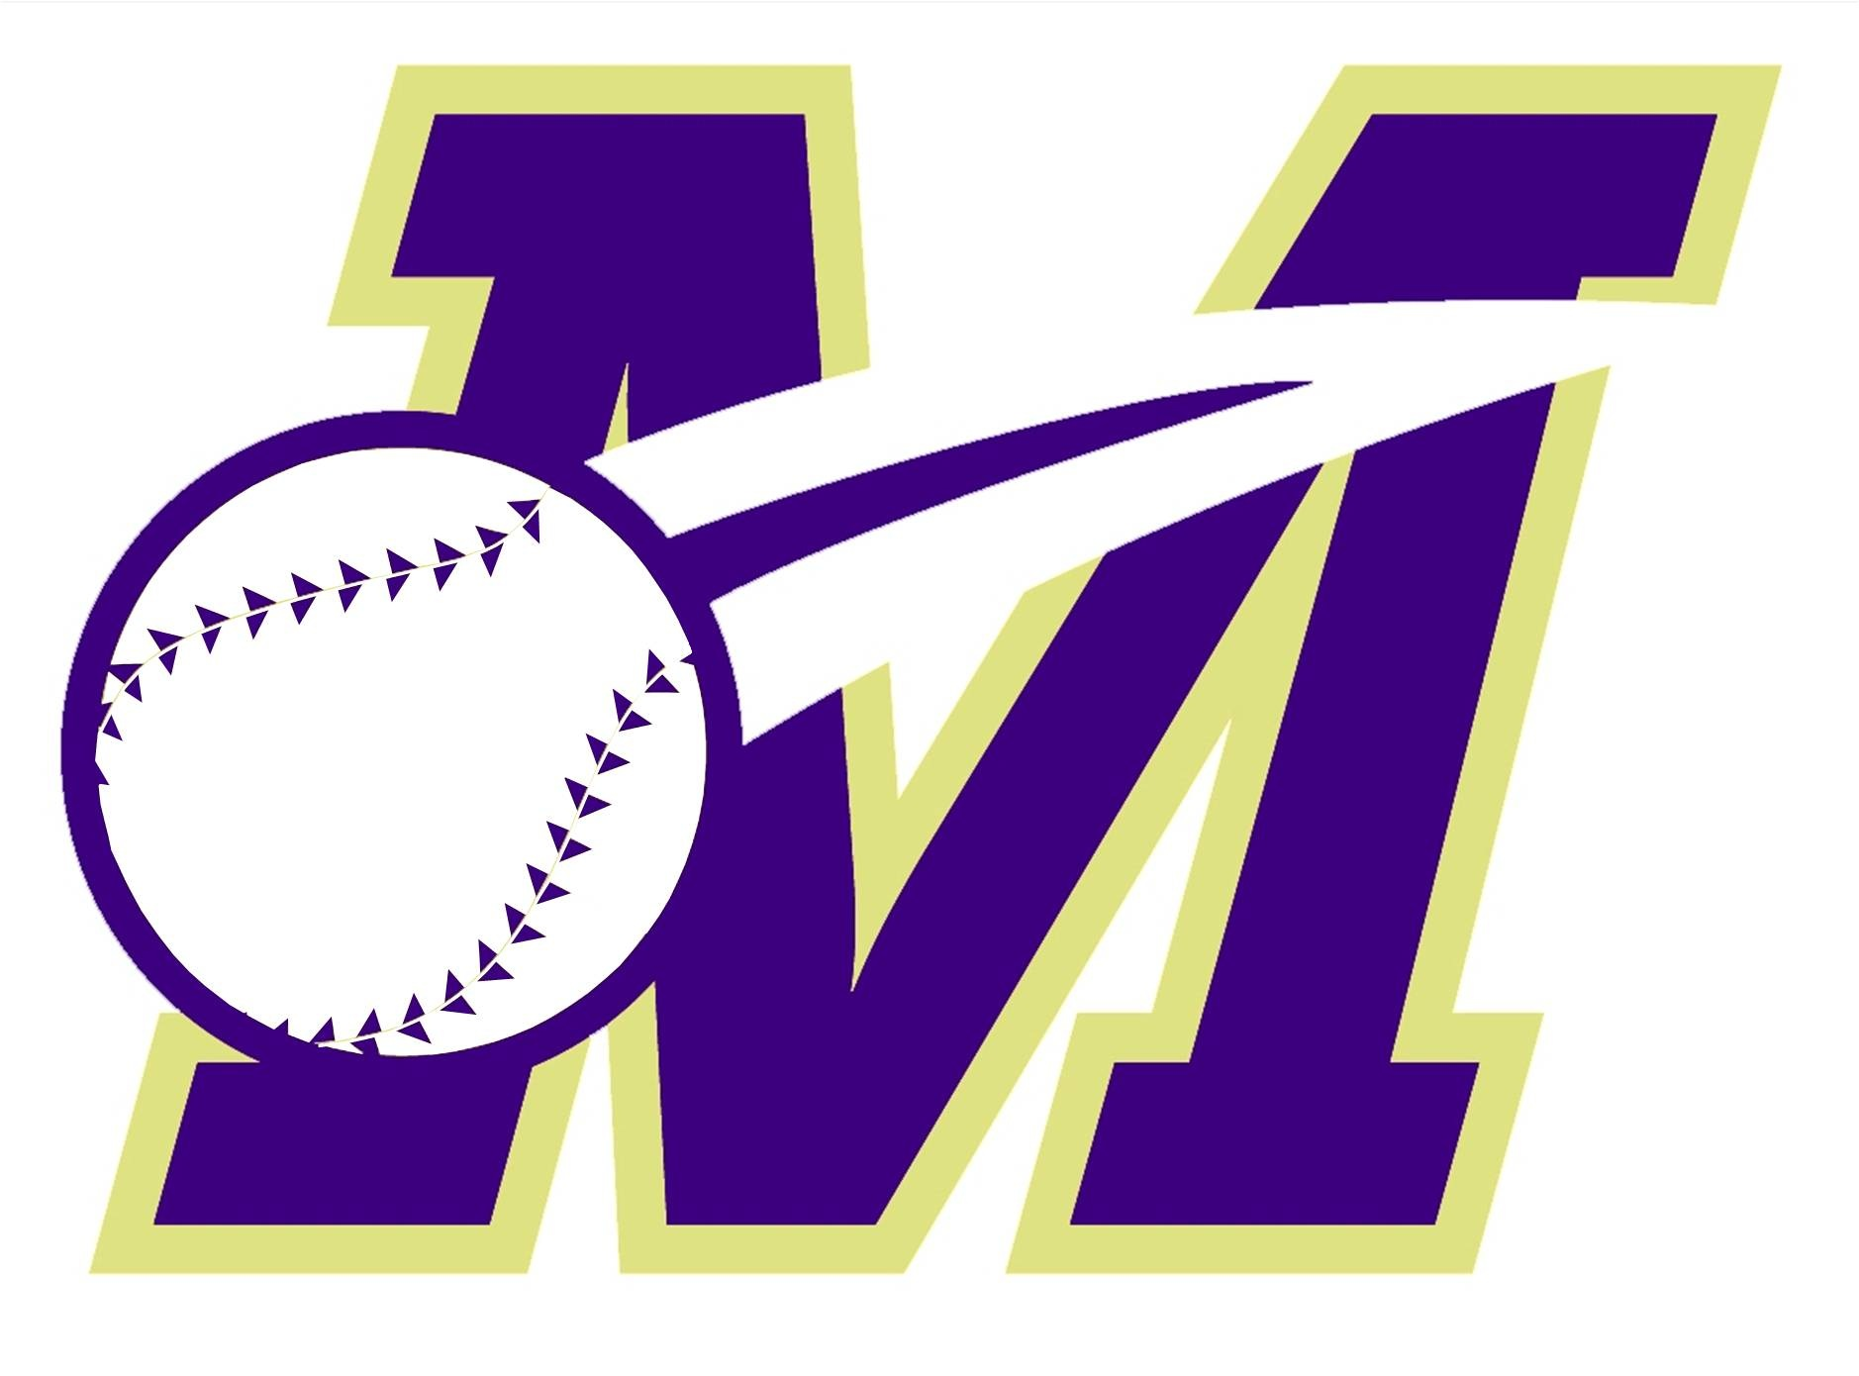 Monroe Township Baseball Association
Proudly Presents….
“Our Annual Scholarship Fundraiser”
Join us for an evening of comedy, fun, food and entertainment
And help raise money for our scholarship efforts!
Buffett Dinner, Raffles & Door prizes

Friday, April 27, 2018
7:00pm to 11:00pm
$50.00 / person
(food, beer, wine & soda included)

Spotswood Knights of Columbus Hall
30 Crescent Ave., Spotswood, NJ 08884
Featuring 2 comedians
Joseph Anthony: Born and raised in New York and a “slightly” stereotypical (yet much more diverse and intelligent) product of such. He now lives in suburban New Jersey and suffers the plight of the middle class –unhappily married, proud father…with just the right amount of angst about society,politics…and well, EVERYTHING!! He’s been a standup comedian since 1989. A straight forward, no filter, monologist. He’s mostly autobiographical, yet speaks voices of many! Not to oversell him, but few Comedians can read & work a room the way he does – it is a talent and some have called it a gift!
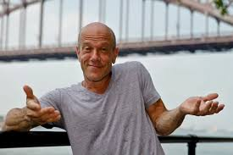Tom Daddario: He has been a stand up comic, performing in and around New York City, for 15 years now. He uses a uniques and refreshing energy on stage, with an interesting twist on his family, friends and relationships. His ability to win over an audience with charisma is its own talent. Tom has made sppearances at clubs such as Stand Up New York, Dangerfields, Gotham Comedy Club, Carolines, Broadway Comedy Club, Mohegan Sun Casino, the Borgata in Atlantic City, Comics at Foxwoods, Turning Stone Casino and The Laugh Factory.
Please RSVP by April 20, 2018:
Mary Loschiavo at m2cute67@aol.com / 732-718-0348 or Lisa Church at lac306@aol.com / 732-485-9628
Mail Checks payable to MTBA to: Loschiavo, 2 Cleveland Avenue, Monroe Township, NJ 08831

