**Monroe Township Baseball Throwing Clinic**

**When: Sundays January 7, 14, 21 and 28**

**Time: 12:30pm-2:00pm or 2:00pm-3:30pm**

**Where: Monroe Twp Rec Center**

**Ages: 7 to 12 (age as of April 30, 2018)**

***\*\*This camp will feature instruction from former MTBA player Marc Magliaro, currently pitching in the Colorado Rockies organization and personal instructor of many of the players on the MTHS baseball team\*\****

* ***Price: $80.00 (covers all 4 weeks / please choose the same time session for each week)***
* ***Checks made out to MTBA***
* ***Register at the Monroe Community Center***

***Email the MTBA with any questions -*** [***monroebaseball@gmail.com***](mailto:monroebaseball@gmail.com)

***Register today, limited space…maximum of 25 participants per session***

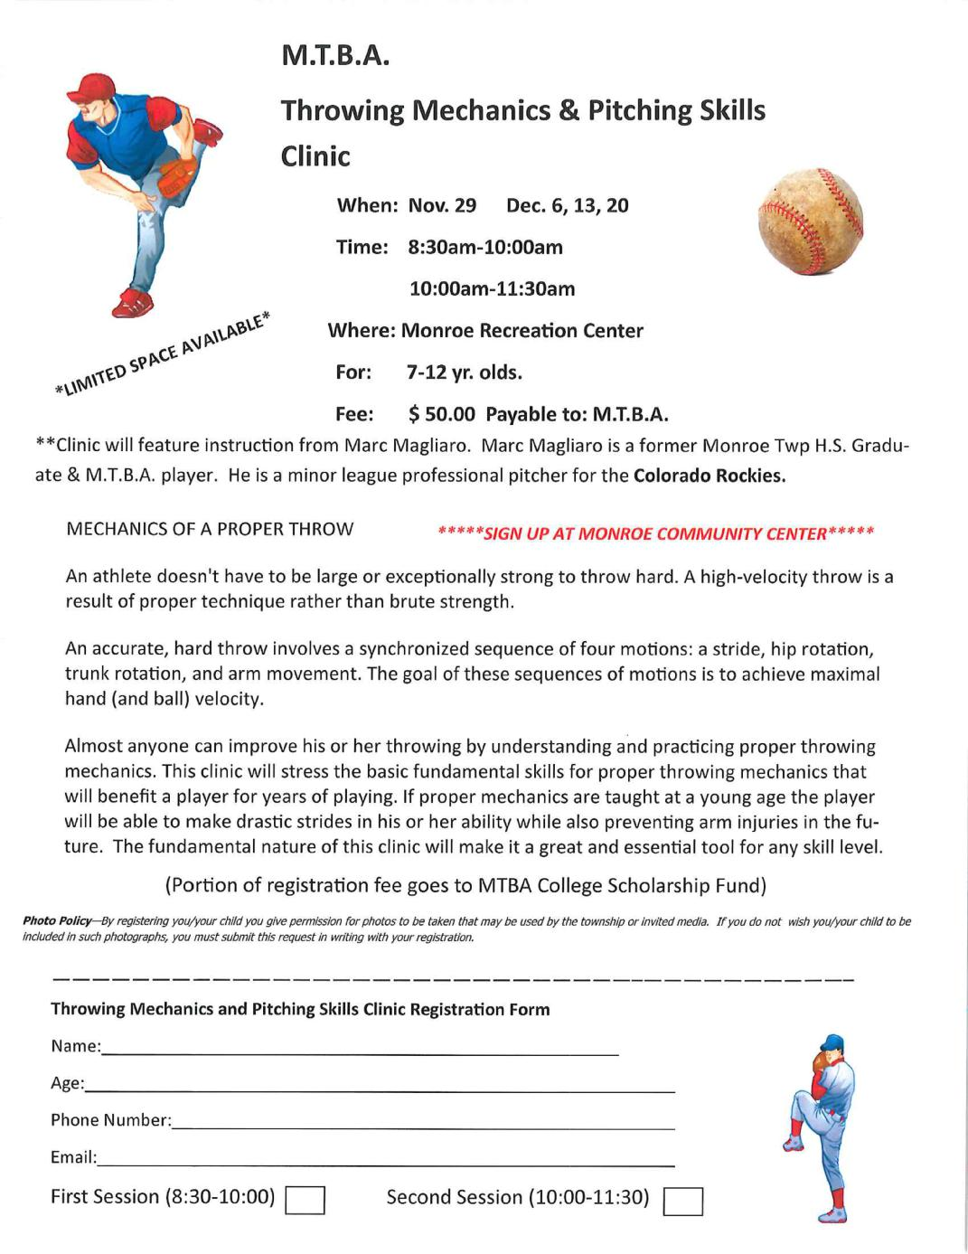

**Choose a Time Below**

**_______________ 12:30pm-2:00pm ______________2:00pm-3:30pm**