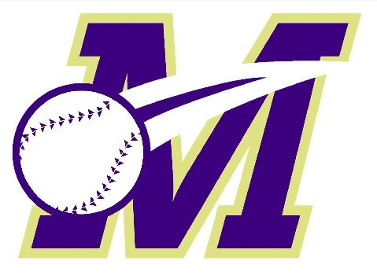
Monroe Township Baseball Association - Free Baseball Clinics

- Learn more about the great game of baseball and the MTBA;
- MTBA coaches and board members will be on hand to discuss the program and answer any questions;
- Improve your baseball skills and prepare for the upcoming baseball season;
- Individual instruction, drills, and more;
- Open to all Monroe and Jamesburg children ages 4 – 12…age as of 4/30/19 (see details below for age-specific clinic dates);
- MTBA officials can assist and answer any questions to those that have not yet registered for the upcoming Rec Baseball season;
Pre-registration for the clinics is required.
Please register at http://www.monroebaseball.com/clinics
*Registration Opens Thursday, January 31*
*To allow as many participants as possible, please register for a maximum of 2 clinics*

FREE CLINIC DATES
Saturday, February 9, 11:00am-12:30pm / Monroe Middle School Gymnasium
- Rec Players only
- Check-in begins at 10:45am, Clinic begins at 11:00am sharp
- For ages 4-12 (age as of April 30, 2019)
Tuesday, February 19, 6:45pm-8:15pm / Monroe Twp Recreation Center
- Rec Players only
- Check-in begins at 6:30pm, Clinic begins at 6:45pm sharp
- For ages 4-8 (age as of April 30, 2019)
Tuesday, March 5, 6:45pm-8:15pm / Monroe Twp Recreation Center
- Rec Players only
- Check-in begins at 6:30pm, Clinic begins at 6:45pm sharp
- For ages 9-12 (age as of April 30, 2019)
Saturday, March 9, 12:30pm-2:00pm / Monroe Middle School Gymnasium
- Rec Players only
- Check-in begins at 12:15pm, Clinic begins at 12:30pm sharp
- For ages 4-12 (age as of April 30, 2019)
* Clinic participants should wear sneakers and shorts or sweat pants. Also bring their baseball glove, helmet and bat.
If you don’t have equipment, don’t worry, there will be equipment there for you to use!

REFERRAL REWARDS! MTBA players, invite a friend who has never played in the MTBA before to attend a clinic. If they register for the spring rec season then you can get a $20 gift certificate to the snack bar at James Monroe Park or Somerset Patriots baseball tickets. To receive the reward you need to tell your friend that when they register they need to put a note in the Special Request field that states - "Referred by <your name>".

Contact monroebaseball@gmail.com with any questions
Please follow and like the MTBA on social media –
Facebook – @MonroeTownshipBaseball
Instagram - @monroe.baseball

