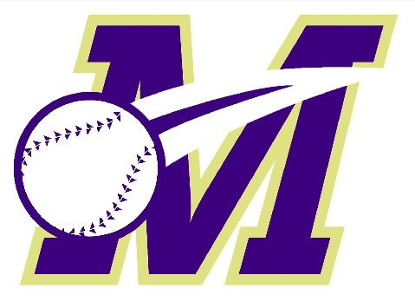
Monroe Township Baseball Association
Free Baseball Clinics

- Learn more about the great game of baseball and the MTBA; league reps will be on hand to discuss the program and answer any questions;
- Improve your baseball skills and prepare for the upcoming baseball season;
- Individual instruction, drills, and more;
- Open to all Monroe and Jamesburg children ages 4 – 12 (see details below for age-specific clinic dates)
- You do not need to be registered for the MTBA spring season to attend, however, MTBA officials can assist those wishing to register during the clinic times / on-site registration available.

Registration is required; please register at http://www.monroebaseball.com/clinics
*Registration Opens Tuesday, January 23*
*To allow as many participants as possible, please register for a maximum of 2 clinics*

CLINIC DATES
Tuesday, January 30, 6:45pm-8:15pm / Mill Lake Elementary School Gymnasium
- Rec Players only
- Check-in begins at 6:30pm, Clinic begins at 6:45pm sharp
- For ages 6-12 (age as of April 30, 2018)
Saturday, February 3, 9:15am-10:45am / Monroe Middle School Gymnasium
- Rec Players only
- Check-in begins at 9:00am, Clinic begins at 9:15am sharp
- For ages 9-12 (age as of April 30, 2018)
Thursday, February 8, 6:45pm-8:15pm / Mill Lake Elementary School Gymnasium
- Rec Players only
- Check-in begins at 6:30pm, Clinic begins at 6:45pm sharp
- For ages 6-12 (age as of April 30, 2018)
Wednesday, February 28, 6:45pm-8:15pm / Mill Lake Elementary School Gymnasium
- Rec Players only
- Check-in begins at 6:30pm, Clinic begins at 6:45pm sharp
- For ages 4-12 (age as of April 30, 2018)
Saturday, March 10, 11:15am-12:45pm / Monroe Middle School Gymnasium
- Rec Players only
- Check-in begins at 11:00am, Clinic begins at 11:15am sharp
- For ages 4-8 (age as of April 30, 2018)

* Clinic participants should wear sneakers and shorts or sweat pants. Also bring their baseball glove, helmet and bat.
If you don’t have equipment, don’t worry, there will be equipment there for you to use!

REFERRAL REWARDS! MTBA players, invite a friend who has never played in the MTBA before to attend a clinic. If they register for the spring rec season then you can get a $20 gift certificate to the snack bar at James Monroe Park or Somerset Patriots baseball tickets. To receive the reward you need to tell your friend that when they register they need to put a note in the Special Request field that states something like "Referred by <your name>".
Contact monroebaseball@gmail.com with any questions

