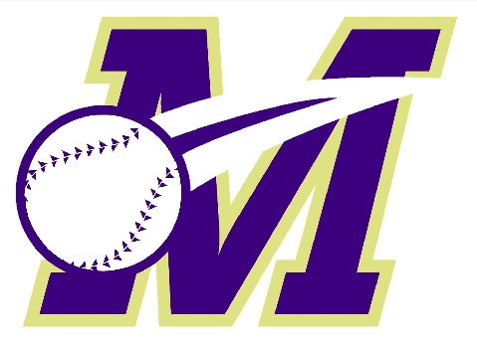
Monroe Township Baseball Association
Work Bond Time Sheet for 2020 Recreation Baseball

Volunteer Name: | MTBA Team:
Address: | MTBA Division:

Work Bond Refund –
- To receive a refund of your work bond, each family is required to devote some volunteer time to the MTBA. Managers, coaches and team parents will automatically be eligible for the work bond refund (no snack bar coverage required). For all others, a minimum of 6 hours plus the snack bar coverage of 1 hour per child is required to satisfy your work bond refund requirement; families with a child/children only playing T-Ball (i.e. no children also in other divisions), 3 hours of volunteer time plus the snack bar requirement is needed for the refund; families with a child/children only playing in Pony, 3 hours of volunteer time (no snack bar requirement). It is the volunteer’s responsibility to properly document the hours you have volunteered. Upon completion of your volunteer activity, you must have your hours validated by your team-manager or other league official (see below).
- Work bond refund checks will be given following the September 2020 and October 2020 MTBA Monthly General Membership meetings at the Monroe Recreation Center and other date(s) to be determined after the Spring 2020 Rec Baseball season. DO NOT GIVE YOUR WORK BOND TIME-SHEET TO YOUR MANAGER AND DO NOT MAIL IT IN! You must turn in your completed, signed work bond sheet at one of these sessions in order to receive your refund. If you fail to submit your completed work bond form at one of these sessions, you will forfeit your work bond to the Association, no exceptions.

Thank you for your service and commitment!

Snack Bar Requirement
(minimum 1 hour required per child; exceptions noted above)
Date | Hours Worked | Verified By: (snack bar)

Other Volunteer Activities
Date | Volunteer Activity | Hours Worked | Verified By: (Mgr or MTBA Official)

FOR MTBA USE ONLY

Check Issued? YES NO Issued By: Check #: Date: .

